Huron Soil and Water Conservation District
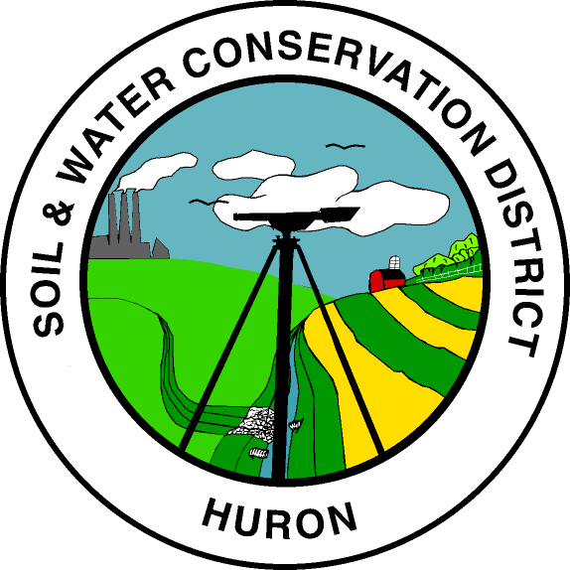
8 Fair Road

Norwalk, Ohio 44857

Phone: (419) 668-4113 ext. #3 Fax: (419)663-8405

www.huronswcd.com

6/1/23

Huron County Soil and Water Conservation District has a job opening for an H2Ohio Technician. The position is funded by a 5-year grant and will pay a starting wage of $15-$18 based on experience. Once the grant ends the Huron Soil and Water Conservation District Board will have the ability to extend the position if funding is available. Please see the job description for all requirements and responsibilities posted on huronswcd.com. Applications or resumes are due June 15th 2023 and can be emailed to chad.stang@oh.nacdnet.net or mailed to 8 Fair Road Norwalk, Ohio 44857. Please contact our office at 419-668-4113 Ext 3 or email Chad with any questions.

Job Title: H2Ohio / District Technician

Summary: The H2Ohio Technician is a 5-year grant funded position starting at $15-$18 per hour based on experience that provides technical assistance on the H2Ohio program. Once the grant has ended the Huron Soil and Water Conservation District Board will have the ability to extend the position if funding is available.

Essential Duties and Responsibilities:
- Help promote the H2Ohio program.
- Assist with verifying program applications and ensure documentation is complete and accurate.
- Ensure that all program activities and practices are properly tracked in Beehive (web-based data entry program).
- Help provide outreach and convey how the H2Ohio program works to landowners and groups.
- Act as a point of contact for the ODA-DSWC for program rules and updates.
- Meet with producers, develop nutrient management plans, review nutrient management plans, discuss Best Management Practices (BMP’s), and complete field checks to verify the plans and rules are being followed.
- Help complete semi-annual reporting on activities and accomplishments as required.
- Other duties and responsibilities as directed by the District Administrator.

Additional Requirements
- Actively promote conservation initiatives and the mission of Huron Soil and Water Conservation District.
- Participate in the team process.
- Maintain safe driving record and have reliable transportation. (Must have less than 6 points on your Driving Record)
- Knowledge and understanding of governing rules, working agreements, regulations and strategic plans specific to Huron SWCD and ODA-Division of Soil Water Conservation
- Attend internal and external meetings.
- Pursue continuous education and professional development opportunities as identified and directed.
- Must be self-motivated and possess the ability to work self-directed with cooperative groups, and interact with the public in the areas of conservation, drainage, and other areas as needed.
- Will be required to pass a drug test for employment.
- Will be required to pass a federal background check.

Qualifications:
To perform this job successfully, an individual must be able to perform each essential duty satisfactorily. The requirements listed below are representative of the knowledge, skill, and/or ability required.

Education/Experience:
Associate Degree or higher in Agriculture (That included classes on nutrient calculations, nutrient management, and conservation practices to limit nutrient runoff). An equivalent combination of some training and at least two years of field experience would also be considered.

Language Ability:
Ability to read and comprehend simple instructions, short correspondence, and memos. Ability to write simple correspondence. Ability to effectively present information in one-on-one and small group situations to customers, clients, and other employees of the organization.

Math Ability:
Ability to calculate figures and amounts such as discounts, interest, commissions, proportions, percentages, area, circumference, and volume. Ability to apply concepts of basic algebra and geometry.

Reasoning Ability:
Ability to apply common sense understanding to carry out instructions furnished in written, oral, or diagram form. Ability to deal with problems involving several concrete variables in standardized situations.

Computer Skills:
To perform this job successfully, an individual should have knowledge of computerized data/information system and software applications, GIS, word processing and spreadsheet software; internet/e-mail.

Work Environment:
The work environment characteristics described here are representative of those an employee encounters while performing the essential functions of this job. While performing the duties of this job, the employee is regularly exposed to outdoor weather conditions and will be required to walk on rough and uneven terrain while conducting on-site field surveys. The employee is frequently exposed to fumes or airborne particles. The employee is occasionally exposed to vibration. The noise level in the work environment is usually moderate.

Physical Demands:
The physical demands described here are representative of those that must be met by an employee to successfully perform the essential functions of this job. While performing the duties of this job the employee is regularly required to stand; walk and sit. The employee is frequently required to talk or hear. The employee must frequently lift and/or move up to 25 pounds and occasionally lift and/or move up to 50 pounds. Reasonable accommodations may be made to enable individuals with disabilities to perform the essential functions.

